Chapter 18, Solution 33.

(a) Let 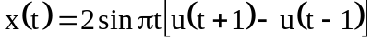

From Problem 17.9(b),

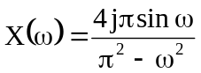
Applying duality property,

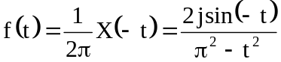
f(t) = 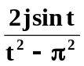

- 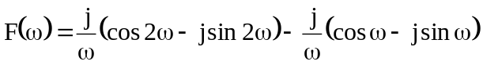
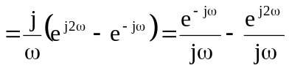
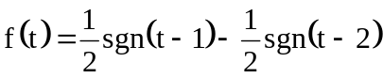
But 
 